Project 14: Motor Driving

1. Description
The robot car is equipped with two DC geared motors, which are developed on the ordinary DC motors. It enjoys a matching gear reduction box, which provides a lower speed but a larger torque. Furthermore, different reduction ratios of the box can provide different speeds and torques.
The reduction motor is the integration of gearmotor and motor, which is applied widely in steel and machine industry.
Moreover, the car boasts a STC8G1K08 and a HR8833MTE chip. To save the IO ports, we send instructions to the STC8G1K08 chip through the IIC of the micro:bit, then the STC8G1K08 chip controls the HR8833MTE chip according to the corresponding instructions to control the rotation direction and speed of the two DC reduction motors (the control process is as follows).
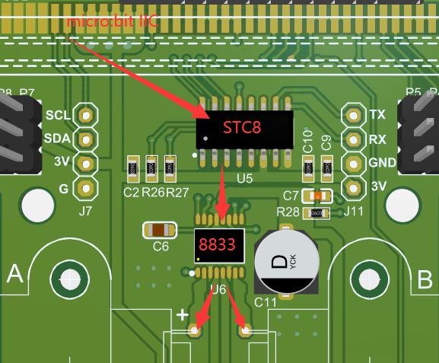

2. Preparation
（1）Insert the micro: bit correctly into the expansion board
（2）Connect the battery holder to the expansion board
（3）Turn on the power switch（Slide the POWER switch to ON end）
（4）Connect the micro：bit and computer via a micro USB cable
（5）Open the Web version of Makecode
If you want to add the Mini car extension library(you can refer to the "1. Development environment configuration "file).

3. Circuit Diagram
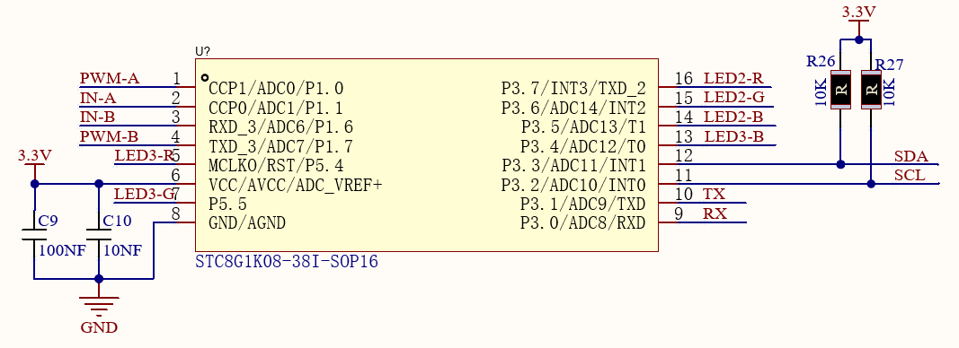
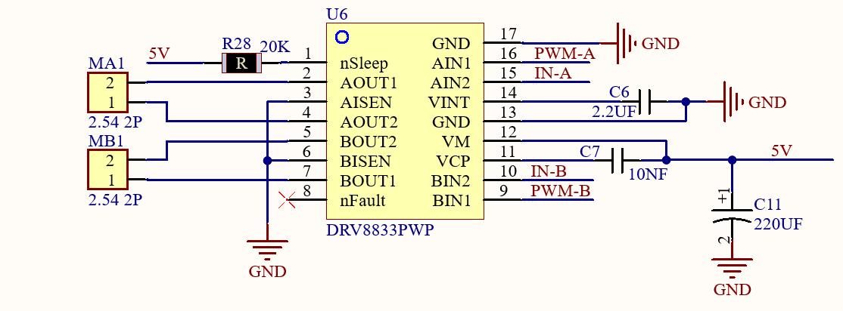

4. Code Explanation
Functions in Keyes_MiniCar.py file：
Motor_L(1, 70): The left wheels will advance with a speed of PWM70
Motor_L(0, 70): The left wheels will move back with a speed of PWM70
Motor_R(1, 70): The right wheels will advance with a speed of PWM70
Motor_R(0, 70): The right wheels will move back with a speed of PWM70
Motor_stop(): The car will stop

5. Test Code
You can upload the“motor.py”code directly from the tutorial (read the "Development Environment Configuration" file if in doubt).
Code:
from microbit import *
from keyes_MiniCar import *
minicar = MiniCar()

while True:
#Forward
minicar.Motor_L(0, 70)
minicar.Motor_R(1, 70)
sleep(1000)
#back
minicar.Motor_L(1, 70)
minicar.Motor_R(0, 70)
sleep(1000)
#turn left
minicar.Motor_L(1, 70)
minicar.Motor_R(1, 70)
sleep(1000)
#turn right
minicar.Motor_L(0, 70)
minicar.Motor_R(0, 70)
sleep(1000)
#stop
minicar.Motor_stop()
sleep(1000)

6. Test Result
Upload the code to the micro:bit board, then turn on the switch at the back of the car, then the car will go forward for 1s, backward for 1s, turn left for 1s, turn right for 1s and stop for 1s.

7. Expanded Knowledge
How to make the motor turn left?
①Set the A motor to backward, the B motor to forward, which is a left turn at the center of the distance between the two wheels.
②Set the A motor to stop, the B motor to forward, which is a left turn at the center of the left motor.
③Set the AB motors to forward, then set the speed of the motor on the left to be smaller than that on the right. In this way, the car will move to the left when moving forward due to the speed difference, and the greater the speed difference, the greater the deviation.
④Set the AB motors to backward, then set the speed of the motor on the left to be greater than that on the right. In this way, the car will move to the left when moving backward due to the speed difference, and the greater the speed difference, the greater the deviation.
The principle of making the car turn right is the same, you only need to switch the motor.

